**Eagle Board Fabrication Tutorial**

## Introduction

I the two previous Eagle tutorials, we covered the basic steps of creating a schematic and board layout for a simple circuit in the Eagle Schematic Capture and Board Layout program. In this tutorial, we use Eagle’s CAM processor to create board description files, called Gerber files, describing each layer of the board for manufacturing.

## Discussion Overview

Gerber files contain location and size information for all the features on a layer. In order for a board fabrication house to manufacture a PCB, they need detailed information for each of the features of the design. For example, for the top layer, the fabrication house will need to have the location and size information for each component pad, and in the case of through hole parts, the drill size for each component pad holes. They also need the information about the size and location of the copper traces on this layer as well as the silk screen layer information about the size, orientation and location of components’ outlines, names, etc.

Eagle uses what’s called a CAM processor to create the Gerber files for all the necessary layers for board fabrication. The next section will walk you through this process step by step.

## Procedure

Start off by loading the board view of your design. Figure 1 shows the layout of the design from our previous tutorial.

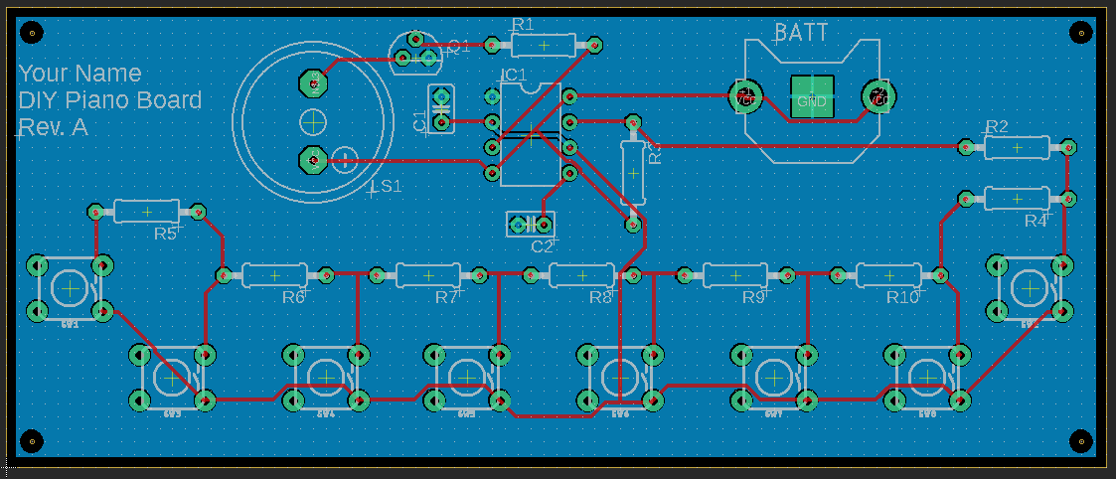

Figure – DIY Piano Board Layout

In order to load your own design, start by cloning and updating your EE-Workshop repo.

1. Clone your EE-Workshop repo to your desktop.
2. If necessary, update your repo by executing the following commands in a command window from the EE-Workshop folder created on your desktop
   1. git fetch upstream
   2. git pull upstream master  
        
      *Note: Above layout is available as a .png image file for your reference in the folder EE-Workshop/Lesson 4/Eagle/DIYpiano folder.*
3. Once you have opened the board view of your design, click on the “Ratsnest” icon  to update the GND pour in the design. Your design should look similar to the one shown in Figure 1.
4. Click on the “CAM Processor” icon  to open the “CAM Processor” dialogue window.  
     
   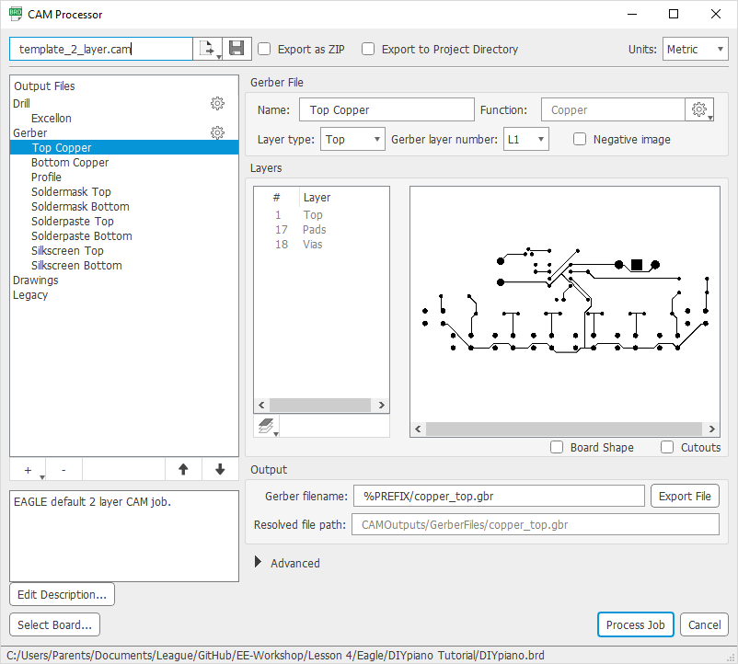  
     
   In this window, we will choose the layers for which we would like to create Gerber files for manufacturing. As you can see, a number of layers have already been included in the default Gerber list in this window. In the right sub-window, you can see the layer information that will be included in the Gerber file associated with this layer.
5. Click on each layer and examine the information for that layer in the “Layers” sub-window on the right. As you can see, there is no information included in the “Solderpaste Top” and Solderpaste Bottom” layers. These layers usually contain information for placing solder paste for manufacturing a board through a solder wave machine. We will remove these files from our list.
6. Right click on the “Solderpaste Top” Gerber and select “Delete”. Do the same for the “Solderpaste Bottom”.
7. Examine “Silkscreen Bottom”. If your design does not contain any information in this layer, go ahead and delete this Gerber as well.  
     
   When done, you should have the following Gerber files:
   1. Top Copper: Contains the information about the copper traces, pads and vias on the top layer of your design. The layers included in this Gerber file are “Top”, “Pads”, “Vias” and “Dimensions”.
   2. Bottom Copper: Contains the information about the copper traces, pads and vias on the bottom layer of your design. As you can see, this Gerber, for example, contains the copper information for the GND fill. The layers included in this Gerber file are “Bottom”, “Pads”, and “Vias”.
   3. Profile: Contains the board shape, dimensions and cutouts. The layers included in this Gerber file are “Board Shape” and “Cutouts”.
   4. Soldermask Top: Contains the openings in the solder mask for the top of the board where metal pads are exposed for soldering. Solder mask is the green material that covers the entire board that protects the metal layer underneath. The layer included in this Gerber file is “tStop”.
   5. Soldermask Bottom: Contains the openings in the solder mask for the bottom of the board where metal pads are exposed for soldering. The layer included in this Gerber file is “bStop”.
   6. Silkscreen Top: Contains component outline and names to be printed on the top of the board. The layers included in this Gerber file are “tPlace” and “tNames”.
8. In addition to the above Gerber files, you can also find a “Drill” file. This file contains the information for the size and location of all the holes that need to be drilled in the board. Click on “Excellon” under the “Drill” file. The settings for this drill file should look as shown below.  
     
   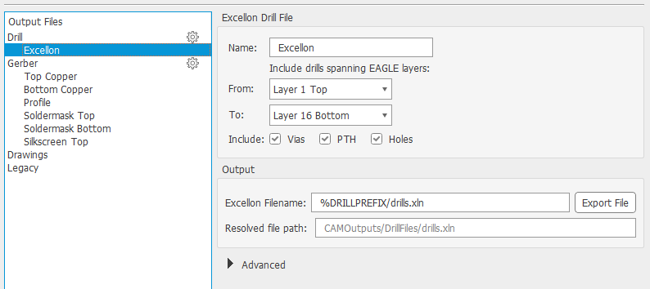
9. Click on the “Gerber” setting icon itself, and you can see a number of settings for the collection of the Gerber files as shown below.  
     
   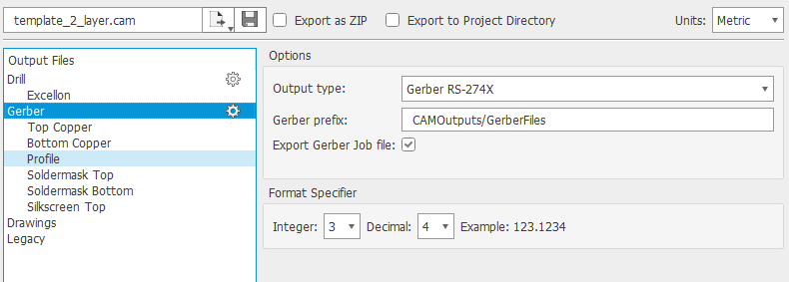
10. Click on “Process Job”. Select your “DIY Piano” folder for the destination of the Gerber files and click “Select Folder”. This will create the files in a folder called “CAMOutputs” under your selected folder. You can click on “Open folder” to examine the files.
11. Ordering boards  
    Next step in our manufacturing process is to upload our Gerber files to a PCB fabrication online service to check the files and order the boards. We will use seeed studio as our board fabrication house.
    1. Load the following URL in your favorite browser: <https://www.seeedstudio.io/fusion_pcb.html>
    2. On this site, you can see a number of settings for the board you’d like to fabricate.  
         
       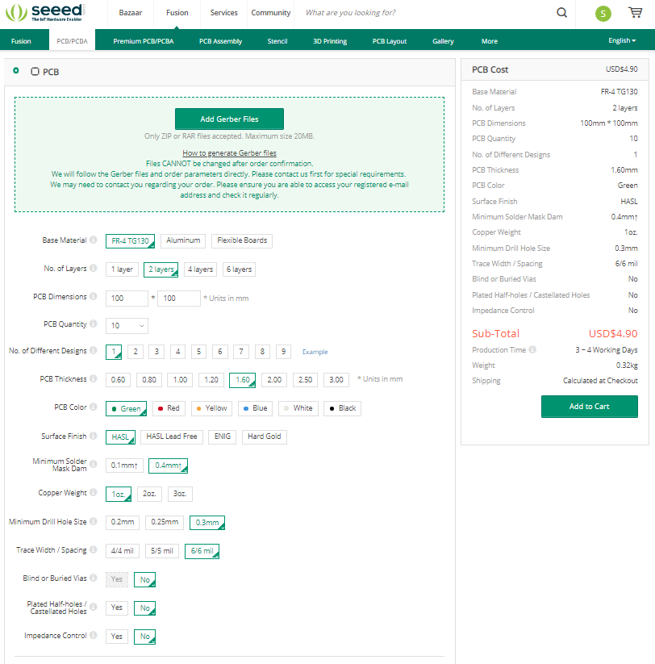  
         
       On the right, you will see a cost estimate for the boards with the configuration/settings selected on the left.
    3. In order to load our Gerber files into their tool, all the relevant files need to be grouped in a ZIP or RAR file.
       1. Open the CAMOutputs/DrillFiles folder and copy the “drills.xln” file into the CAMOutputs/GerberFiles folder.
       2. Select all the Gerber files (all the files with .gbr extension) and the “drills.xln” file and compress them into a single ZIP file called DIYpianoGerber.zip. Make sure the “gerber_job.gbrjob” file is not included.  
            
          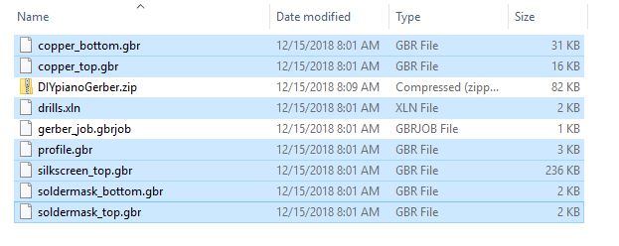
    4. On Seeed’s PCB site, click on “Add Gerber Files” and upload the DIYpianoGerber.zip file.
    5. Once the file has been uploaded, click on the “Gerber Viewer” to examine the board layers.  
         
       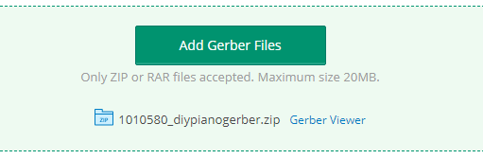
    6. In the Gerber viewer, check to see if there are any “Error Messages”. If there are any errors in the upload process, they will show up here.  
         
       You can also check each layer uploaded by turning on the layer from the list of available layers on the left. For example, in the image below, the “Top Copper”, “Top Silkscreen” and “Top Solder Mask” layers have been turned on.  
         
       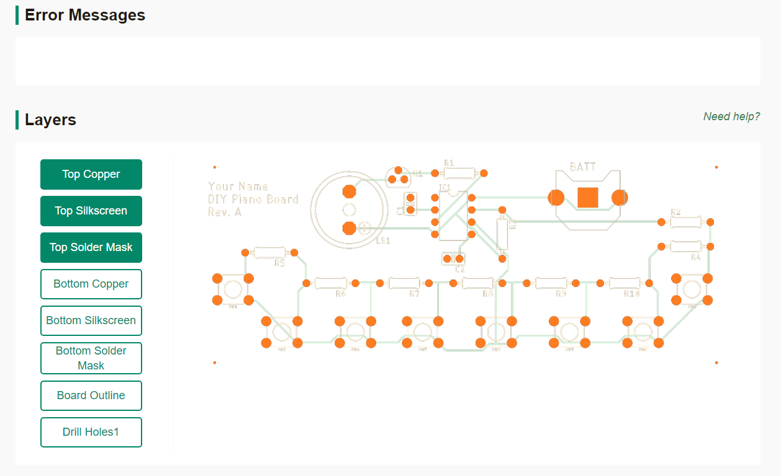

Figure - Uplaoded Gerber File Viewer

* 1. Return back to Seeed’s PCB page where you had uploaded the files. You can see that the PCB dimensions and number of layers have already been filled in based on the Gerber files you just uploaded. Set the remaining options as follows.
     1. Base Material: FR-4 TG130
     2. No. of Layers: 2 Layers
     3. PCB Quantity: 5
     4. No. of Different Designs: 1
     5. PCB Thickness: 1.60mm
     6. PCB Color: Select your desired color
     7. Surface Finish: HASL
     8. Minimum Solder Mask Dam: 0.4mm
     9. Copper Weight: 1oz.
     10. Minimum Drill Hole Size: 0.3mm
     11. Trace Width/Spacing: 6/6mil
     12. Blind or Buried Vias: No
     13. Plated Half-holes/Castellated Holes: No
     14. Impedance Control: No
  2. Click on “Add to Cart”.
  3. Click on the cart icon to proceed to checkout.

## Appendix – Useful Links

Schematic capture in Eagle:

<https://www.youtube.com/watch?v=1AXwjZoyNno>

Laying out a board in Eagle:

<https://www.youtube.com/watch?v=CCTs0mNXY24>